Economic review: Impact of tax on developing countries with special reference to GST India
Srinivasan P
VIT Business school, VIT University, Vellore, India.

Abstract— GST (Good and service Tax) is the newly implemented taxation system India, and it is a single tax rate all over India. And it is GST one of the biggest indirect tax reforms in the country. The motto to expect to bring economic growth of state and central. GST levied by the central of India. It creates simplification and removal of multiple valuation of tax. And also, will reduce cost of production. Ease of registration in a single registration process. Cash flow has improved. Supply chain restructuring and elaborate transaction management.

Index Terms—GST (Good and service Tax), GST India, taxation system.

INTRODUCTION
A Tax is a compulsory contribution, paid by an individual or company to the local or national government. Levying of taxes, which aim to generate revenue to the government and its spread to all the people in the form of development. Taxes are reality of life for all of us, rich and middle-class or low. In case of failure to pay to taxation, is punishable by law.GST brings in uniform tax system across all the states. Divided between the Central and State government. SGST, CGST, IGST. There is expectation that the new taxation system will boost the Indian economy and huge shift from unorganized to organized. Its straightly affect the consumer purchasing power, In case higher tax rates. If the tax rates under the line of acceptable tax structure, it reflects on consumer purchasing mechanism.
2. RESEARCH PROBLEM
GST (good and service tax) is one of the biggest economic reform in the country which reflects on all over the world. Identification the expected and reality of implication of GST and return to meet the target.
3. OBJECTIVES OF THE STUDY
- To study the impact of good and service tax (GST) on Indian economy
- To study about the expectation and reality of implication of GST
- To understand the taxation reforms of India
4. RESEARCH METHODOLOGY
The study framed on the study of secondary data collected from various national & international journals, government reports, websites and various books. Focused on aspects of goods and service tax.

5. TAX SYSTEM:
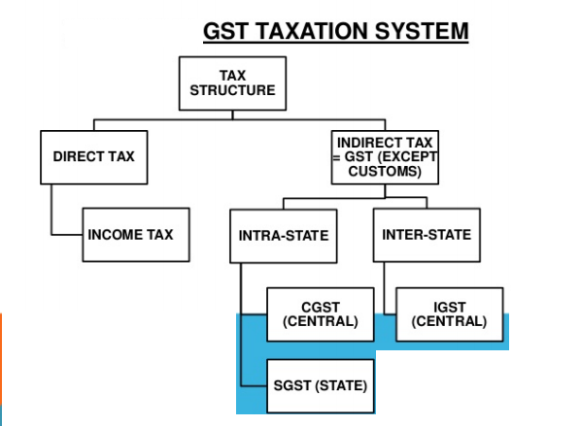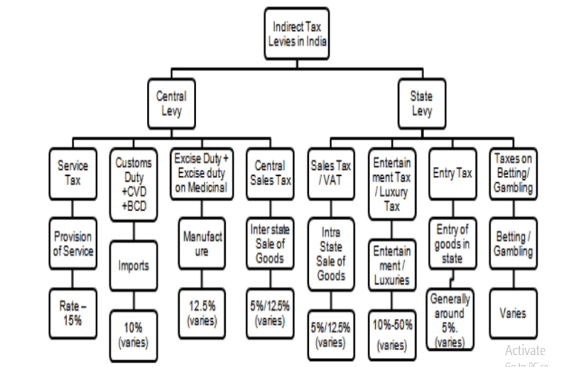

6. TAX STRUCTURE:
Under GST, goods and services are taxed at the following rates, 0%, 5%, 12%, 18% and 28%. There is a special rate of 0.25% on rough precious and semi-precious stones and 3% on gold. In addition a CESS of 22% or other rates on top of 28% GST applies on few items like aerated drinks, luxury cars and tobacco products. GST replaced a slew of indirect taxes with a unified tax and is therefore set to dramatically reshape the country's 2 trillion dollar economy.
IMPACTON ECONOMIC GROWTH:
It gives single tax systems which reduce the price of goods and services due to cascading elimination. Removal of bundled indirect taxes like VAT, CST, Service tax, CAD, SAD and Excise. It will increase in employment opportunities in long run.Development of common national market to the traders. It helps to boost export making their product more competitive in the international market, boost manufacturing activities to leading sustainable economic growth. Uniform SGST and IGST rate to reduce the incentive for tax evasion. Boost the Indian economy in the long run and lower the tax burden on the common man i.e. people will have to pay less money to buy the same products that were costlier early. Control on black money circulation and as the system followed by traders and shopkeepers because of mandatory check. GST will allow to get better negotiate in terms of international trade forums, it aimed tax payer by bringing SME’s and unorganized sector under its compliance.

BENEFITS OF GST:
For business and industry | For Central and State Governments | For the consumer
Easy compliance | Simple and easy to administer | Single and Transparent tax proportionate to the value of goods and services
Removal of cascading effect | Better controls on leakage | Reduction of prices
Improved competitiveness | Consolidation of tax base
 | Higher revenue efficiency

GST INDIA VERSUS GST IN THE OTHER COUNTRIES:
- So far, a total of 160 countries have opted GST.
- India has highest GST rate at 18% compared to emerging market economics.
- India has two types of GST hence called as dual GST.
The GST council has set tax rates for goods and services under five brackets of 0%, 5%, 12% and 28%.
Concept of GST is not new to the world as nearly 160 countries as on 2016, have opted this mode for bringing individually tax rates into a single tax. In most countries value added tax (VAT) is taken as a substitute for GST.

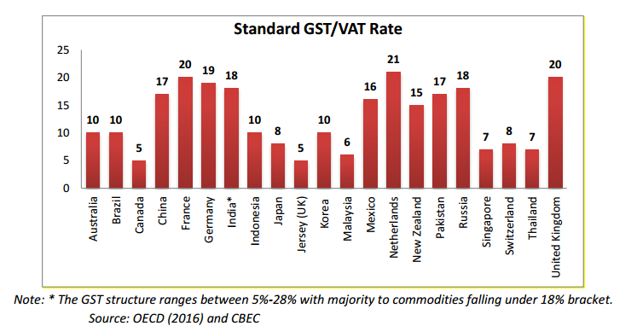
Countries like Canada, Australia, Singapore, New Zealand, U.K, Malaysia, Indonesia, and Pakistan have a GST system but while remaining follow a VAT system.
Some of the developed countries like s like France, Germany and United Kingdom have higher GST rates set between 19 – 20%.
Comparison with emerging market economics (EMEs), India has highest rate of GST at 18% - with major commodities falling under this rate. EMEs like China and Brazil have their most of commodities falling under the tax rate of 17%, 10% respectively.

WHAT DIFFERENTIATES INDIA?
Government of India has structured GST for efficient tax collection, ease of interstate movement of goods etc and reduction in corruption.
Differentiation between GST in India and GST in other countries is that, in India two types (SGST and CGST) of GST is charged - hence called as duel GST.
"Unlike India, other countries have a much higher threshold for GST applicability thus reducing the burden for small businesses. This will bring in challenges for our SMEs."

HOW GST IS GOING TO HELP BELOW THE POVERTY LINE?
Thus, the GST should benefit all sections of the society. Additionally, the GST, being a nationwide tax, could lead to possibly higher inflation in the first few years of its introduction but would gradually increase the overall GDP. those living below the poverty line, there might not be a direct impact of the GST on them as such since basic necessities like food are unlikely to attract the GST but increased collections of the GST with a larger tax base should provide an impetus to the government to allocate more money for social and poverty alleviation programmers.
HOW WILL GST HELP GDP GROWTH?
A study done by NCAER that shows the impact on growth due to reduction in cost reduction and direct cost on capital inputs pegged the improvement in growth rates between 2 and 2.5 per cent.
HOW GOOD AND SERVICE TAX WILL IMPACT SECTORS?
FMCG/retail fast moving consumer goods sector will benefit from the GST tax due to the present of big unorganized market. GST rate for products like soaps, hair oil and toothpaste has been low by 500-600 bps from the previous rates. will benefit from the move. companies such as Colgate-Palmolive, hull, Britannia, heritage foods etc

Company | GST Rate Impact | Preparedness | Overall Impact
Dabur | Overall neutral | Dealers will be protected | Weak volume growth in Q1
Marico | Neutral to positive | Teething issues over tax credits, small vendors aren’t compliant yet | Low to negative growth expected
Shoppers Stop | Garment prices to go up | Large vendors ready, small vendors are unprepared | Possible supply disruptions expected post-GST
Source: Edelweiss Securities
Small Business Preparedness
Sector | GST Preparedness Amongst Small Vendors | Overall Impact on Industry
Pharmaceuticals | Most participants in trade not geared up for GST | India sales for industry will be impacted in Q1
Luggage | Higher rate of 28% to slow down the pace of shift from unorganized to organized | Post Q1, expect pickup from 7-8 July onwards
Cement | Largely an organized sector and hence large dealers mostly compliant | No major inventory impact expected
Plywood | Dealers, distributors and vendors are not prepared for GST rollout | Q1 FY’18 sales to be impacted
Tiles | Transition stock related issues troubling dealers | Margins to be impacted due to loss of input credit on gas and freight cost

PHARMA AND HEALTHCARE SECTOR
Earlier rate of 10% now that the pharmaceutical products will be 12 per cent GST. The inputs by the Pharma and health care sector will be taxed at the rate of 18 per cent; it leads to raise the operational costs. However, the health care sector will remain exempt from GST. Companies like Dr LAL path labs will be benefit.
ON CONSUMER DURABLES
Despite the category being placed under the highest tax slab of 28 per cent under GST. The consumer durable industry is marginal price revision, slightly more than previous tax structure. There will be some increase in the price of most consumer durable items when GST came into picture. Keep on eye companies like Crompton Greaves, Whirlpool, Havells and Voltas, Symphony. Consumer durable firms unlikely to pass on tax burden to buyers “Home appliances have become a necessity now with evolving consumer lifestyle and a lower tax slab would have made appliances more affordable in a low-penetrated market. Panasonic India Chief Financial Officer Manish Gupta said they expect a revision in prices of select category. "Normal monsoons and the resultant boost to the agricultural economy and hike in allowances to government employees will propel demand.
THE EFFECT OF THE GST ON INDIAN GROWTH
World Bank says India will grow 7.2% in FY18, GST will deliver substantial gains” The fact that India can achieve a major reform of indirect taxes without increasing the burden on the poor is in itself an achievement. Adding to this, the efficiency gains that the tax will achieve and the fact that the information generated through the GST on spending patterns will facilitate enforcement of personal and corporate income taxes, the impact of the GST introduction on equity and poverty should be positive,” it said.

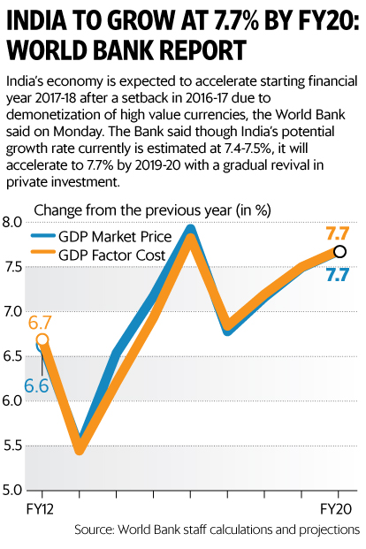

GST- LIST

List of the things to get cheaper

- Buying a car, tea, coffee, toiletries, coal, two wheelers, mobile phones, entry level sedans.AC train travels, rental cabs/radio taxi, budget hotels, air travel, telecom, tour operators service, non-a/c eat outs, Televisions, Movie Tickets, Processed Foods, Cement.

List of things exempted
Milk, unpacked cereals, salt, newspaper, condoms, contraceptives, postal service, electricity, education, healthcare, legal service, animal slaughter, lottery & funeral service
- List of the things to get Expensive are
- Eating out a/c hotels, processed food, aerated drinks, small cars, appliances, cinemas gambling, casinos, sporting events, financial transactions, insurance premiums, Phone Bills, Jewelry, Online Shopping, Banking & Insurance, Travelling.

SUGGESTIONS AND RECOMMONDATION
The following points might help in lowering the effects of GST with making it supportable by different segment of tax payers:
- The lash down in the percentages of GST charged to support MSME, medium, large scale industries and also growing business (startup).
- To provide additional time to start the practice of GST into the taxation system, after correction in the clause mentioned.
- To form law and regulation before being implemented such that the law will error free are with minimum change acceptance.
- To setup a regional and district based GST campaign too enlighten the brighter side and its contribution to economy development and growth.
- Seasonal reduction in GST such that during downward trend/ recession phase of business there can cut in GST for time.
CONCLUSION
GST will bring in corruption free tax administration and transparent. in developing countries, direct taxation has limited scope and hence indirect taxation plays a more significant role.GST allow India to better negotiate in the terms in the international trade forums. In the short run, it may affect the growth of economy due to various reasons like lack of people awareness. GST aimed at increasing the taxpayer base by bringing SMEs and the unorganized sector under its compliance. This reform will make Indian market more stable than before and sustainable, Indian companies can compete with foreign companies.
REFERENCES
[1] The effect of the GST on Indian growth by Eva van Leemput and Ellen a. Wiencek-march 2017

[2]India GDP growth to re-accelerate as GST impact fades: Morgan

[3] GST will contribute to India’s GDP growth: moody’s vp

[4] Poonam, m. (2017). goods and services tax in India: an. 6th international conference on recent trends in engineering, science and management, 9.

[5] GST: an economic overview: challenges and impact ahead prof. pooja. s.kawle, prof. yogesh .l. aher

[6]. impact of GSTt on automobile sector in india v. lavanya

[7].http://www.gstindia.com/about/

[8].The role of tax in developing countries by jonnae rolling

